Abstract For k-TSP scoring and code

Introduction k-TSP

Background
Identifying cancer-related gene expression patterns is challenging because many tumors and normal tissues look similar under laboratory examination.

The Top-Scoring Pair (TSP) method offers a simple, parameter-free classification approach that relies only on the relative ordering of two genes. This eliminates the need for data normalization or complex tuning and helps reduce overfitting in small-sample,high-dimensional microarray datasets.

Relative Expression Reversal

The k-Top-Scoring Pairs (k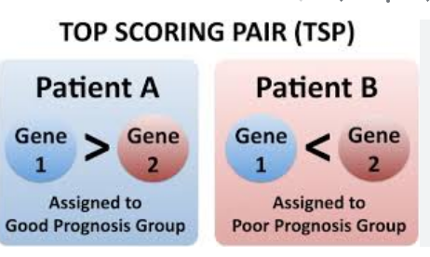-TSP) algorithm generalizes TSP by combining k informative gene pairs to improve predictive performance while retaining interpretability. When k = 1, the method reduces to the classical TSP algorithm. Both TSP and k-TSP are grounded in the concept of relative expression reversals between classes, which makes them particularly effective for “small-N, large-P” bioinformatics settings where the number of samples is small but the number of genes is extremely large.
Compared with traditional classifiers such as support vector machines (SVM), decision trees, k-nearest neighbors, and Bayesian models, k-TSP provides a simple yet powerful framework that avoids model complexity and reduces risk of overfitting. Its rule-based decision structure also allows intuitive biological interpretation.
For multi-class classification problems, TSP and k-TSP can be applied using common decomposition strategies, including one-vs-rest, one-vs-one, and hierarchical classification frameworks. These extensions enable flexible adaptation of the method to a wide range of cancer gene expression studies.

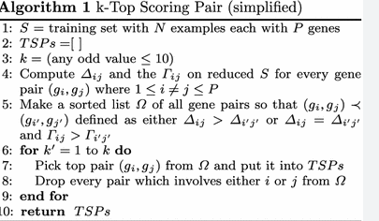

2.2 analysis for KTSP

Considering a dataset with P genes measured in N samples, represents as a matrix of size P × N.Each sample n is a column vector xn=(x1,n,…,xP,n)x_n = (x_{1,n}, …, x_{P,n})xn​=(x1,n​,…,xP,n​), and each sample has a class label yny_nyn​.
The training set is S={(x1,y1),…,(xN,yN)}S = {(x_1, y_1), …, (x_N, y_N)\}S={(x1​,y1​),…,(xN​,yN​)}, where all samples are assumed to be independent and identically distributed.
The TSP classifier is a rank-based method: its decision rule depends only on the relative ordering of gene expression values, not on their absolute values.
A drawback is that the top-scoring gene pair can change if a few training samples are added or removed, making the classifier unstable.
The k-TSP classifier addresses this by selecting k disjoint top-scoring gene pairs instead of just one.
By combining several weaker rules, k-TSP acts like an ensemble classifier that is more stable and generally more accurate.
An efficient algorithm is used to compute cross-validation errors during training.
Sample1 Sample2 … SampleN
Gene1 x1,1 x1,2 x1,N
Gene2 x2,1 x2,2 x2,N
...
GeneP xP,1 xP,2 xP,N

The TSP classifiers are rank-based, meaning that the decision rules only depend on the relative ordering of the gene expression values within each profile.
1.In some instances, the TSPs may change when the training data are perturbed by adding or deleting a few examples.
2.Here, we introduce the k-TSP classifier, which extends the TSP classifier, and is designed to deal with this problem, as well as increase the accuracy of the TSP classifier, by generating a more stable classifier.
3.This is accomplished by basing the classification on the k disjoint Top Scoring Pairs (k-TSP) of genes that achieve the best combined score.
4.We can view the k-TSP as an ensemble learning approach where the intention is to combine the discriminating power of many ‘weaker’ rules to make more reliable predictions.
5.devised an algorithm that employs an efficient computational shortcut to calculate the cross-validation error.
6.Prediction for kTSP,Given a new profile xnew, each gene pair (iu,ju), u = 1,…,k, determines an individual classifier hu(xnew) … This yields k predictions of ynew.
7.The k-TSP classifier hk-TSP employs an unweighted majority voting procedure to obtain the final prediction of ynew; … simply chooses the class receiving the most votes.

3.Code analysis

3.1 Data loading

• Read the dataset file
Each dataset is stored as a text file. The function reads all lines from the file.
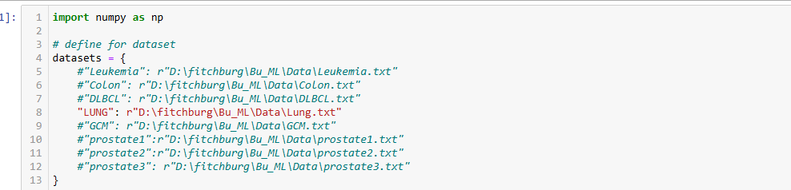
• Detect whether the first row contains labels
If the first row contains non-numeric values, these are treated as sample labels.
If the first row is numeric (such as in prostate2/prostate3 datasets), the code assumes that labels are missing and assigns them manually (first half “tumor”, second half “normal”).
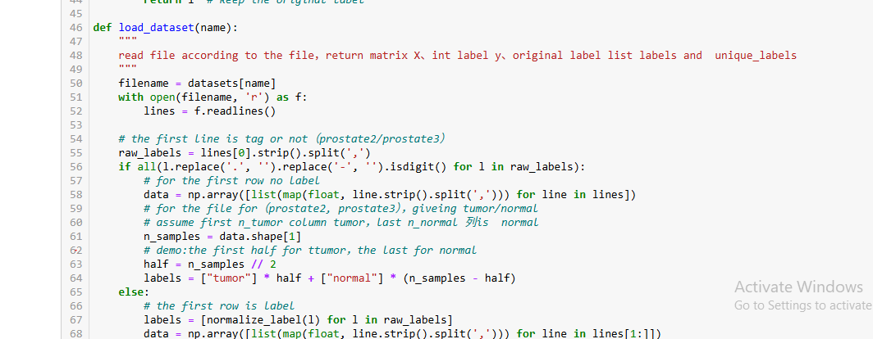
• Load gene expression matrix
The numerical values are stored in an array data.
If the data is in the shape (samples, features) instead of (features, samples), the code automatically transposes it.

• Convert labels to integer classes
The function collects all unique labels, sorts them, and assigns integer codes:

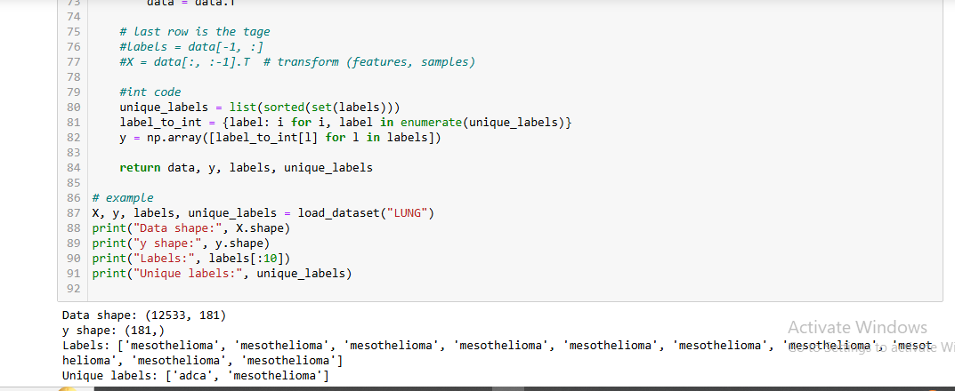

3.2 Method of model algorithm.

3.2.1KTopScoringPairs:
This class implements the k-TSP algorithm.
It stores:K: number of top-scoring gene pairs to select
pairs: the selected K gene pairs.
scores: the classification score for each pair
feature_names: optional list of gene names

Training (fit method)
def fit(self, X, y):
Input:
X with shape (n_genes, n_samples)
y with class labels (0/1)
The method:
Iterates through all possible gene pairs using combinations.
Computes a pairwise score for each pair using _pair_score.
Sorts the scores and selects the top K best-discriminating pairs.
This step corresponds to training a k-TSP classifier.
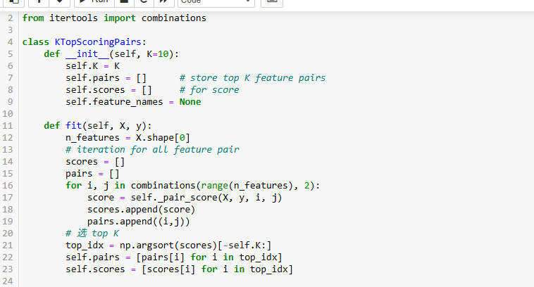

ScoringFunction
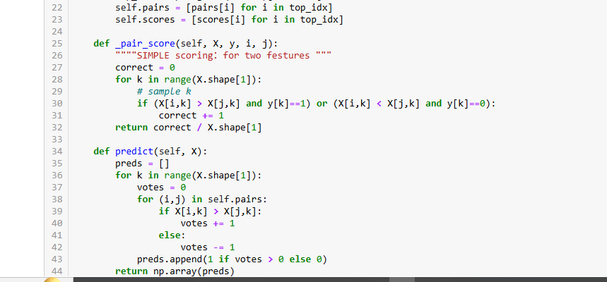
def _pair_score(self, X, y, i, j):
Computes how well gene pair (i, j) separates two classes.
For each sample:
If gene i > gene j, predict class 1
Else predict class 0
Accuracy over all samples is returned as the pair’s score.
This is the core of TSP/k-TSP: only the relative ordering of two genes matters.

Prediction
def predict(self, X):

For each sample, each selected gene pair casts a vote:
gene i > gene j → vote +1
gene i < gene j → vote –1
Final class = majority vote over K pairs.
implements the standard unweighted majority voting of k-TSP.

This class represents a node in the classification tree.

classifier: stores a trained binary classifier (such as k-TSP)

left / right: pointers to child nodes

label: used when this node is a leaf (final class)

pairs: stores the top gene pairs used in this node (for interpretation)

3.2.3. HierarchicalClassifier — Overall Tree
base_model = function that trains a binary model (e.g., k-TSP)
root = root node of the hierarchical tree
Finds all classes
Builds the hierarchical tree from top to bottom

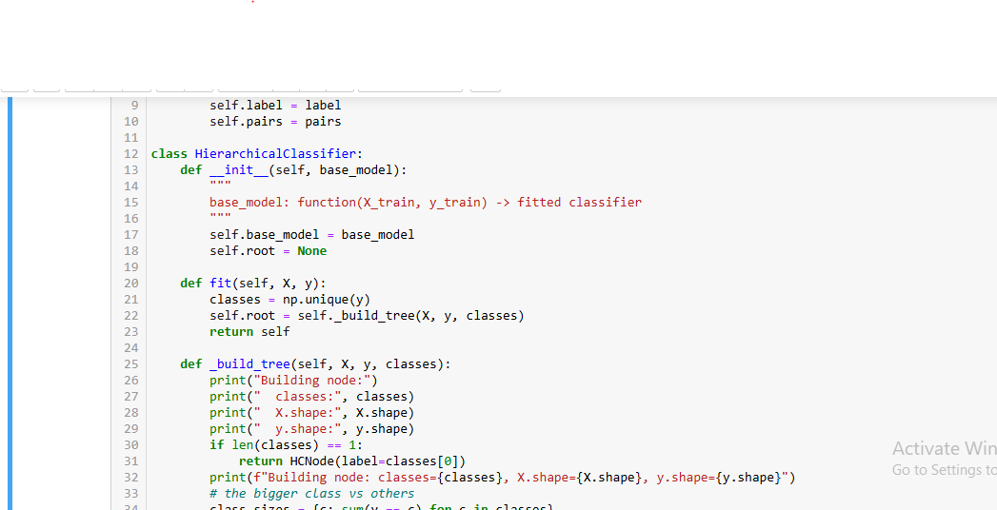
4.1 fit() — Construct the tree
4.2 _build_tree() — Recursive Tree Building
4.4 Train a binary classifier at this node
4.5 Split data into left (largest class) and right (others)
4.6 Recursively build left and right subtrees , Return this new node
5. predict() — Apply Tree to New Samples
6. _predict_single() — Follow Tree Path
7. get_all_pairs() — Extract Important Gene

3.2.4 Processing data
Split train and test data
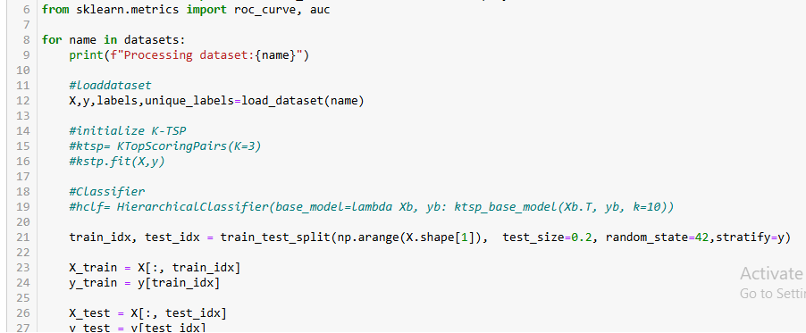

Using kstp model and HierarchicalClassifier
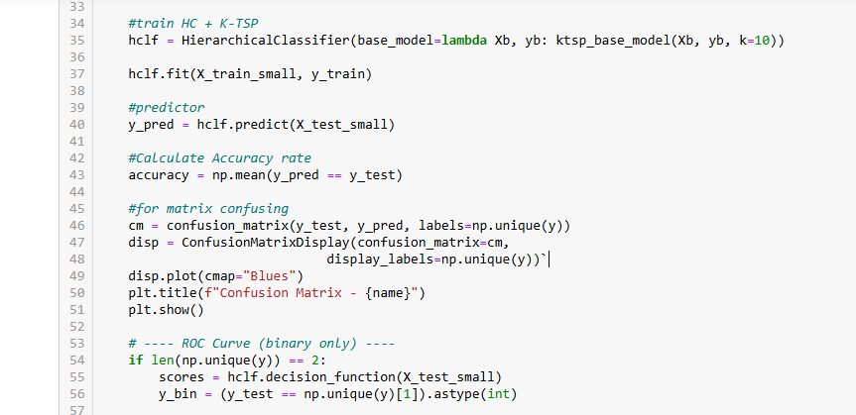
Visualize the test data
